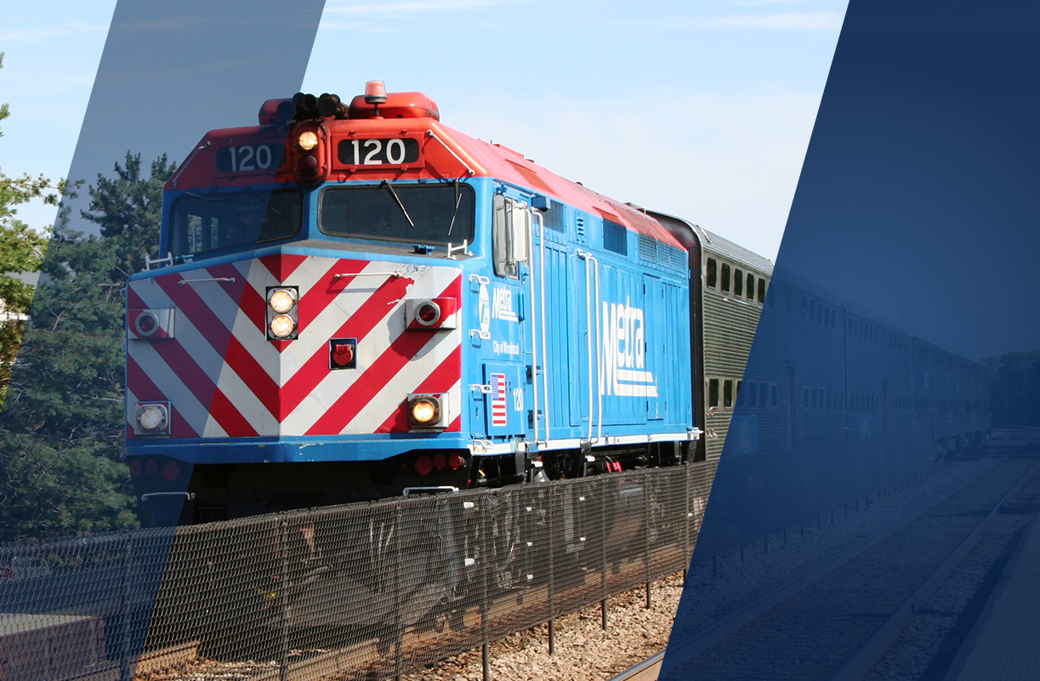
Metra Website Training: Authors & Editors

Table of Contents
Table of Contents 2
1. Purpose of This Guide 3
2. Global Site Features 3
2.1. Signing in and Basic Account Information: Training 3
2.2. Explanation of Metra Administrative Roles 4
2.3. Workflow Publishing/Rejecting for Each Role 6
2.4. Locating Content to Perform Edits 6
2.5. Publishing Content 6
2.6. Versioning and Rolling Back to an Earlier Version 7
3. Creating Main Site Content 7
3.1. Content Types Overview 7
3.2. Default Page 8
3.3. Page - Safety 9
4. Appendices 10
4.1. Summary of Rich-Text Toolbar (WYSIWYG Editor) 10
4.2. Meta Tag Best Practices 11

Purpose of This Guide
This is intended to serve as a guide during in-person training for the Metrarail.com site.

The permanent guidelines will be located within the website administrative tools on the Dashboard as “CMS Instructions.”

What we are covering today:
- Overview of the Drupal administration tools
- Content editing and creation for basic pages
- Concept of workflow

Global Site Features

Signing in and Basic Account Information: Training

Two Environments:

- Staging (Training): This is the “sandbox” used for training and testing purposes. Any content you add to the staging environment site will not be public-facing, even if it is published in this environment. Any content added to the staging environment that should be added to the public-facing site must be re-added to production and published in that environment in order to become “live”. Only Metra site administrators have access to view and edit content in the staging environment.
STAGING URL = https://stage.metratest.com

- Production: This is the “live site” used only for valid, public-facing content. Any content you add and publish in this environment will be visible to all website visitors.
PRODUCTION URL: https://metrarail.com

Create a New Account:
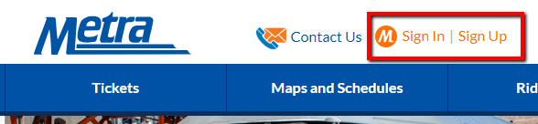
- Click on the MyMetra Sign In link in the global header
- Click on “Create Account” in the left-hand menu
- Enter email, choose a password, confirm the password, add your first & last name, and then click on the “Sign Up” button to trigger the verification email to be sent.
- You should receive an email shortly that will contain instructions to verify your account so that you can login. Once you click the verification link within the email, you’ll be redirected back to the site where you’ll be required to enter your password again.

NOTE: This verification process will happen individually on Staging and in Production. You will be required to register and login on both sites separately.

Login to Existing Account:
- Click on the MyMetra Sign In link in the global header.
- Sign in using the username created for your account along with the password.

Reset Your Password:
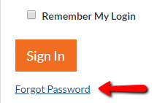
- On the Sign In page, click the “Forgot Password” link below the Sign In button or in the left-hand menu.
- On the Forgot Password page, enter your email and click “Submit”.
- Check your email for a verification email from communications@metramail.com with the subject of “[Metra] Password Reset Request. Click on the link within the body of the email to confirm your request and reset your password.
- From the Change Password page, enter your new password twice and click the “Change Password” button. Note: the new password must be different than your old password.

Edit Account Information
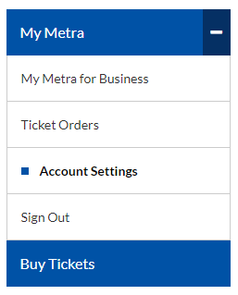
- Once logged into MyMetra, an administrator can update first and last name, email address, phone number, and password associated with the account by clicking on “Account Settings” in the left-hand menu.
- From the Account Settings page, click the “edit” link to the right of the information that needs updating.
- Add the new information to the appropriate field(s) and click “Submit” when finished. The new information will be associated with only the account that you changed. Staging and Production accounts are maintained separately.

Explanation of Metra Administrative Roles
Site permissions are divided into two groups: Department-Specific and Site-Wide.

Department-Specific Roles
Most admin users in the system will have an Author or Editor role under one or more departments. These department-specific roles are given permissions based on the content types your department will have access to create, edit, and publish. If needed, one person can have multiple roles. For example, a user could be an Author role for one Department and an Editor role in another Department.

Author
- Can create and edit specific content types for publication, dependent on their department
- Can push content to “Needs Review” status
- Cannot publish content

Editor
- Can create and edit specific content types, dependent on their department
- Can approve content for publishing submitted by Authors in their department
- Can push content to “Needs Published” status
- Cannot publish content directly to site, but is final departmental review

Department Publisher
- Specific departments (i.e. Procurement, HR, Transportation) have department publishers that can create, edit, or publish select content types within their departmental roles
- Can make select content live by choosing “Published” status
- Manages select content publishing and revisioning for a particular content type within the department
- Can view and revert any revisions of a particular content type within the department

Site-Wide Role
Site Publisher
- Can create, edit, and publish any content
- Can make content live by choosing “Published” status
- Manages content publishing and revisioning for all content types across all departments
- Can view and revert any revisions
- Can feature content on the home page and add to the main and mega menus

Summary of Roles
Department | Author | Editor | Dept. Publisher | Site Publisher
External Communications | C, E | C, E, S |  | C, E, S, P, F  (All Depts.)
Engineering | C, E | C, E, S
Marketing | C, E | C, E, S
Law | C, E | C, E, S
HR | C, E | C, E, S | C, E, S, P  (Career Content)
OBDCR | C, E | C, E, S
Planning | C, E | C, E, S
Procurement | C, E | C, E, S | C, E, S, P  (Bid Content)
Safety | C, E | C, E, S
Station Services | C, E | C, E, S
Transportation | C, E | C, E, S | C, E, S, P  (Alert Content)
EEO | C, E | C, E, S
C = Can Create content within this department
E = Can Edit content within this department
S = Can Submit content for Publishing within this department
P = Can Publish content within this department
F = Can Feature content on the homepage, menus, or within this department

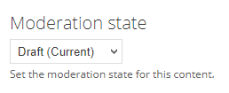
Workflow Publishing/Rejecting for Each Role
The publishing workflow for Metrarail.com is based on the tried and true publishing workflow in the print industry. Authors submit content to Editors who can either accept, reject, or re-edit the materials for publication. Departmental or Site Editors then review, revise, and publish content.

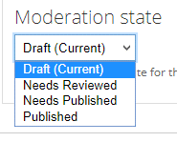
As an Author: You can create new content, or revisions to existing content within your department. Your content must then be set to “Needs Review” to be seen by Editors for review. Your content will not be visible on the site until an Editor has reviewed your content and a Publisher has made it “live” on the site.

As an Editor: You can create new content, edit existing content, and set content as “Needs Published” for any content submitted by an Author, or that you authored yourself.

As a Publisher (Site or Department): You can create new content, edit existing content and set content as “Published” for any content submitted by an Author, Editor, or that you authored yourself.

Locating Content to Perform Edits
A logged in user with the appropriate editing rights can access the content for editing in three different ways:

- My Workbench - Clicking “My Workbench” in the administration menu will show your recently edited content, and if you are an Editor or a Publisher - all recent content by users within your department.

- Dashboard - - Clicking “Dashboard” in the administration menu will show your recently edited content, as well as content in states of moderation.

- In-Page Context - Depending on the type and placement of the content, there will either be:
  - Tabs displaying VIEW | EDIT | MODERATE in the page.
  - A link to “edit this item” next to the actual item on the page (i.e. Alerts, etc.).

When you are editing content, you can save any work in progress by clicking on the save button at the bottom.
IMPORTANT: There is no auto-save functionality.

Publishing Content
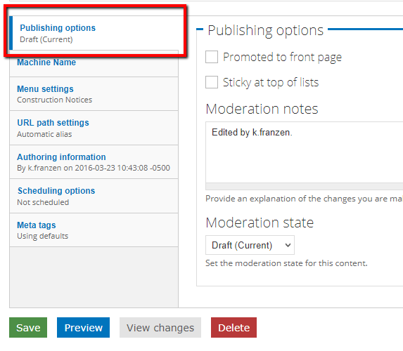
At the bottom of the content item, admin can quickly save a draft of their work by clicking the green “Save” button. However, if the draft is ready for review or publishing (i.e. moderation), then the admin will need to select the desired “Moderation state” from the Publishing options tab visible at the bottom of the page. Clicking “Save” after the moderation state is changed, will save the content item in that state and trigger any notifications necessary.

The Publishing options tab also allows admin to add notes about the revision (what and why edits were made, notes about when to publish, etc.) prior to changing the moderation to “Needs Review” or “Needs Published” in the “Moderation state” dropdown menu. Publishers will have the extra option of “Published” in the dropdown menu as they have the permission to publish content directly to the public-facing site.

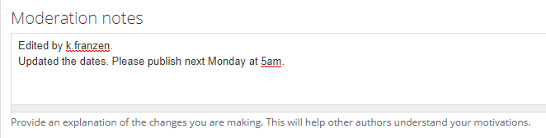

Versioning and Rolling Back to an Earlier Version
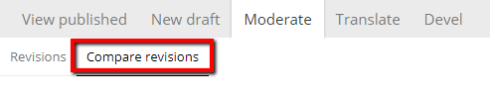
If an item of content has had more than one revision, an additional tab “Moderate” will appear next to the “View Published” and “New Draft” tabs across the top of the page.
- Clicking the tab will show each revision of the content, who edited it, and when it was edited.

- Clicking Compare revisions selecting 2 revisions and clicking Compare will show a side-by-side comparison of those revisions, highlighting any differences in red text. Note: The highlighted view will include both text content and code.
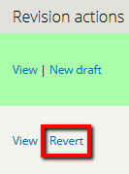
- Clicking on a linked title for a specific instance will show you that revision.

- Clicking on “revert” (and confirming), will make the chosen version the most recent revision of the content. Authors and Editors may revert to an earlier revision, but only Publishers may publish an earlier revision.

Creating Main Site Content

Content Types Overview
Drupal, like most other content management systems, uses a templating system to display content. Different templates are used because each content type does not share a common structure. The data fields entered for a news item (e.g. date, documents) are different than data fields entered for a business location (e.g. address, phone, hours), so they each require different content types.

It would be overwhelming to have every piece of content using the same “mega-template,” as unused fields would be confusing for the person entering content.

The specifics of creating the following content types are detailed in the sections below:
- Default Page
- Page – Safety

Default Page
One of the most basic content types in Metrarail.com is the Default Page. This content type consists of a Title and a Rich-Text (WYSIWYG) Editor. Most departments will have a department-specific version of this type of Default Page, but the administrative fields will look the same.

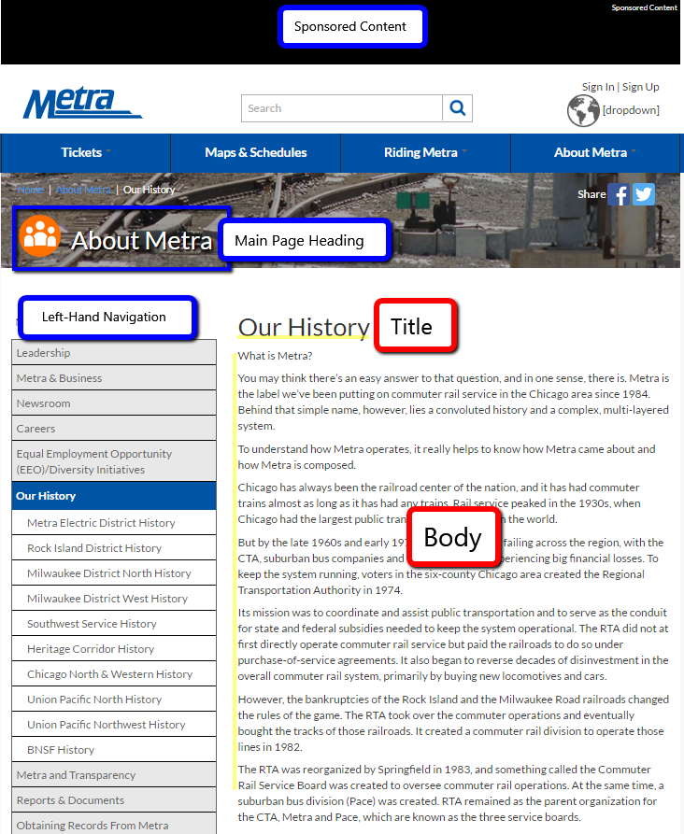
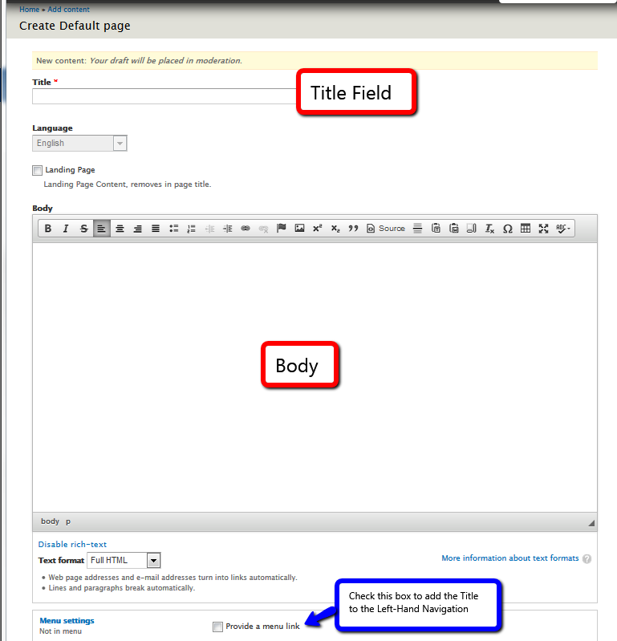
Prerequisites:

Department(s):
External Communications

Roles:
Author, Editor, Site Publisher

Content:
“Parent” Pages must be created first before any “Child” pages for menu hierarchy purposes.
(i.e. Our History = Parent Page, Metra Electric District History = Child Page.)
To Create a new Default Page:

- From the administrative toolbar, Choose Content -> Add Content -> Default Page. Here you will see all of the fields (presented linearly) that make up the core content of each Default Page.

- Each field is labeled and has help text. You will fill out the required (*) sections as needed and click “save” when complete. Details of each field and their final presentation are shown in the figures above and right.

Page - Safety
One of the department-specific basic pages includes Page – Safety. These basic pages will act similarly to a Default Page with a title field and a WYSIWYG Editor to enter content into the Body of the page.
To Create a new Page - Safety:

- From the administrative toolbar, Choose Content -> Add Content -> Page - Safety. Here you will see all of the fields (presented linearly) that make up the core content of each Page - Safety.

- Each field is labeled and has help text. You will fill out the required (*) sections as needed and click “save” when complete. An example of a Page – Safety is shown in the figure to the right.

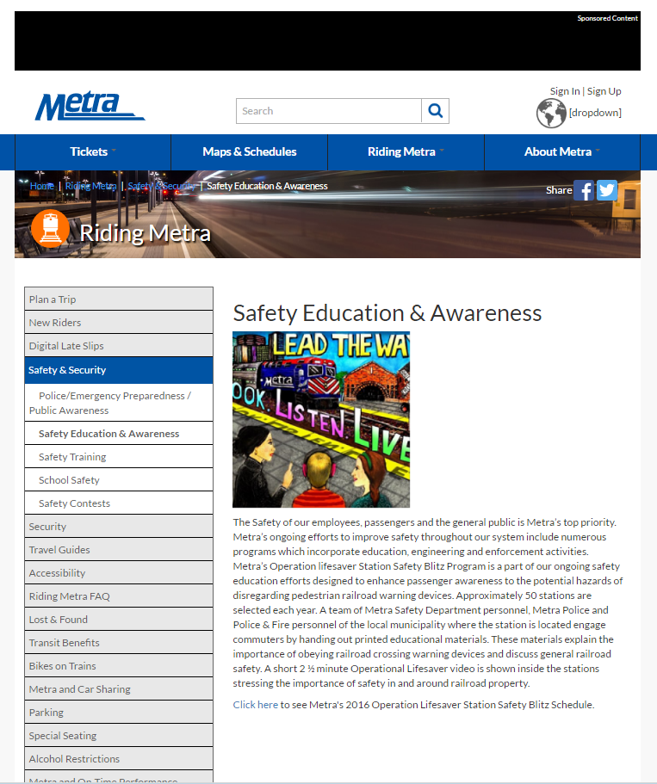
Prerequisites:

Department(s):
External Communications, Safety

Roles:
Safety Author, Safety Editor, Site Publisher

Content:
“Parent” Pages must be created first before any “Child” pages for menu hierarchy purposes.
(i.e. Our History = Parent Page, Metra Electric District History = Child Page.)

Appendices

Summary of Rich-Text Toolbar (WYSIWYG Editor)
Bold - makes text bold
Italics - makes text italics
Strikethrough - adds a strikethrough to text
Turns selected text into a bulleted list. (Carriage return to start the next bullet)
Turns selected text into a numbered list. (Carriage return to start the next bullet)
Indent text. Can be pressed multiple times to indent further. Use this to nest items in a numbered/ bulleted list
Out dent. Reverses the action on a previous indent action.
Link. Add a link to the selection. Link properties include choosing the target window of the link. Target “_blank” opens the link in a new window, which is used when linking to an external site.
Un link. Remove a link from the selection. (selection must be a link.)
Anchor. Adds an invisible, in-page anchor that can be used to link to a position on the page.
Media. Add an in-line image or video in the WYSIWYG. Place your cursor in the area where you would like the media to appear, then click this button to select or upload media.
Superscript - use this to add superscript text
Subscript - use this to add subscript text
Block quote. Produces indented text that is stylized with a 3-pixel line along the left side of the text (Different than “indent” button)
Source - view the code source of the page. Comes in handy for troubleshooting any odd formatting that is not easily removable. (Note: not available to all user roles.)
Horizontal Rule - adds a horizontal rule into the page.
Paste as plain text - Use this button to “strip out” all formatting of the text on your system clipboard. Formatting will have to be applied using the toolbar buttons. This is useful when you are pasting from a source that has formatting that is beyond repair, but the text content is valuable.
Paste from Word - use this button to “strip out” all extraneous Word formatting data from the text on your system clipboard -- while retaining the important structural formatting.
Show blocks - Shows the “invisible” structure of the page. Similar to how word can show demarcations of paragraphs and tabs within the page.
Remove format - If you want to remove all formatting from a selection, use this. Note that it will not scrub stray characters that would have been eliminated using either of the “paste from” tools.
Insert special character - Allows non-keyboard ANSCII characters to be used.
Table - Used to insert tablature data. This is not meant to be used for page layout or positioning.
Maximize - If the text editing area is feeling too claustrophobic, you can maximize the text area to match the size of your browser window. Clicking the button again minimizes it back to the original size where you can continue to edit the page.
Spell Checker – click on the button and select “Check Spelling” to check the entire Body field or highlight a portion of text to check separately. Click on alternate spellings within the dialog box if any errors are identified.
Add Video – add a URL of a YouTube video to your content and specify the height, width, and alignment of the video preview.

Meta Tag Best Practices
Meta tags are largely an automated task in Drupal.

Page title -- This is the link that comes up at the bold title link in search results. It uses the values ([node:title] | [site:name]) that were entered for the page’s title, and also the site’s name. You can manually edit all or part of value, but generally users expect the link they click to lead to a page that is directly related to the text of the link that they just clicked.
Description -- This is the small snippet that accompanies the title/link in search results.
Abstract -- You can enter a summary of the page here, possibly adding synonyms for topics covered in the page.
Keywords -- You can enter comma-separated values, touching on the major points of the page. Due to abuse known as “keyword stuffing”, most search engines ignore this field and simply summarize the page’s content using their own algorithm. They are still used by the site’s internal search engine.

Read more about how to best write meta tags here: http://www.hobo-web.co.uk/definitive-guide-to-using-important-meta-tags/

